**Honeyline String Art**

Automatic DIY multi-color String-Art from (almost) any image

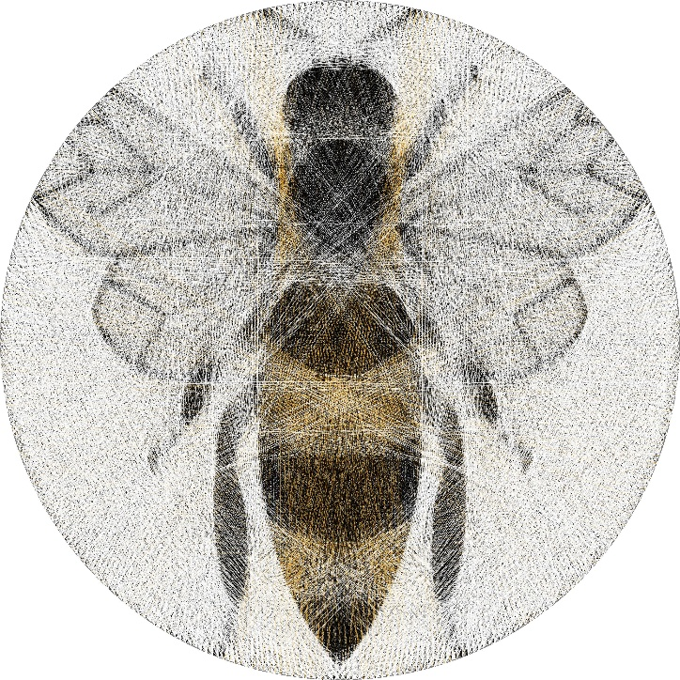

<https://github.com/roy-hachnochi/string-art>

Based on the inspiringly creative work by Petros Vrellis:

A New Way to Knit (2016)

<https://artof01.com/vrellis/works/knit.html>

**General Instructions**

**Materials:**

* Hardboard/wooden base – at least 1 cm thick.
* Optional – card stock paper, or paint, of your desired background color (white/gray/black).
* Galvanized metal nails – 2 cm long, 2mm head.
* Recommended thread thickness: 0.12-0.14 mm (40 TKT), see next page for thread lengths.
* *The next page contains instructions on how to set up the nails on the canvas. You may use a slightly different canvas size, but* ***do not change the number of nails****. To measure the nail positions:*
  + *For a circular canvas, use a protractor.*
  + *For a rectangular canvas, use a ruler.*
* *Please* ***pay attention to the nail numbering****, as the result highly depends on the correct numbering and orientation. It is recommended to highlight every 10th nail for ease of finding the correct one.*
* *Start threading:*
  + *On the first nail of each color, make 3-4 tight knots.*
  + *Pull the thread to the next nail and loop around it, no need to make a knot.*
  + *The full nail sequence is divided into groups to make following the instructions easier, use the checkboxes next to each group to track your progress.*
  + ***Don’t apply too much tension*** *to the thread when connecting nails – it may result in the nails breaking. But –* ***apply enough tension*** *to keep the thread connected.*
  + *When changing colors, it is recommended to secure the thread on the nail with a knot.*
  + *When done with a thread, make 3-4 knots around the final nail.*
  + *Cut the loose remainders with scissors.*

**Preview Simulation**

**String-Art Instructions**

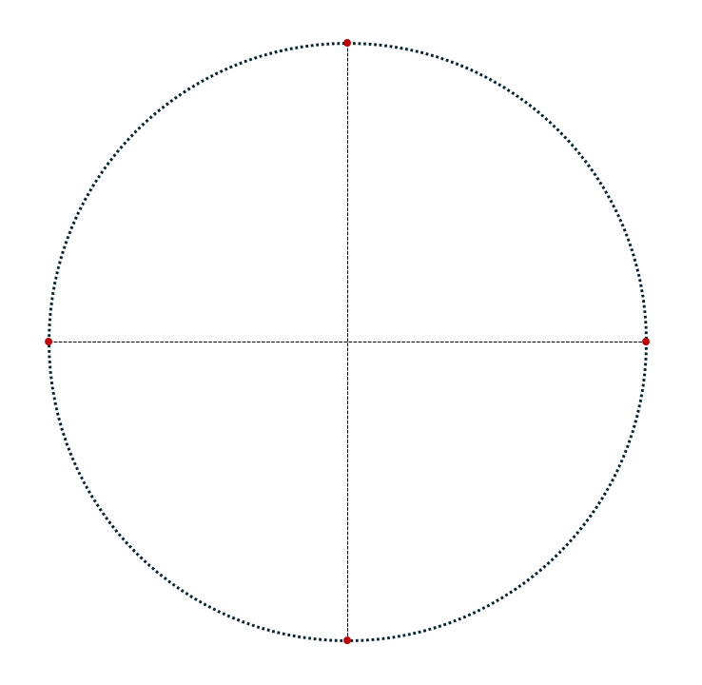

**String-Art Instructions**

